Google Analytics User Manual

Google Analytics is a tool that is utilized in our application to accomplish the goal of tracking various user behaviors on the website, including what pages are most frequently visited as well as what users are clicking while they are on the pages. This tool has a user friendly UI and is easy to navigate, understand, as well as configure. To access google analytics, first navigate to the website at the link following link:

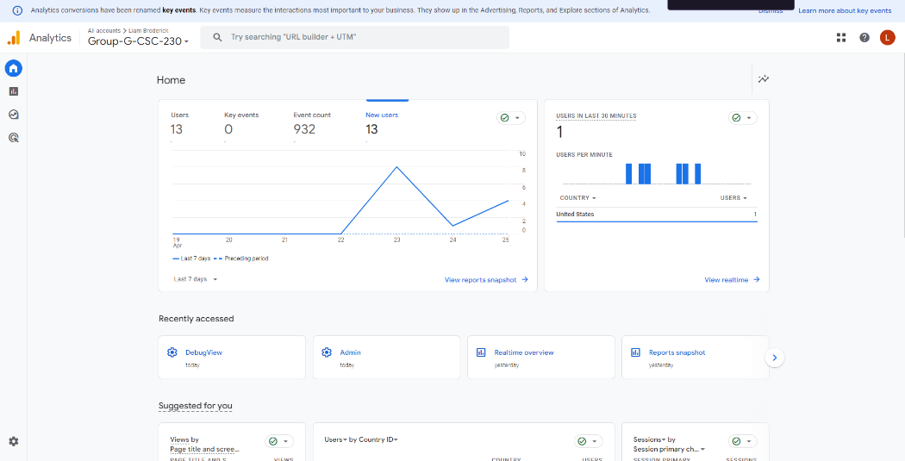<https://analytics.google.com/analytics/web/?utm_source=marketingplatform.google.com&utm_medium=et&utm_campaign=marketingplatform.google.com%2Fabout%2Fanalytics%2F#/p437726643/reports/intelligenthome?params=_u..nav%3Dmaui>

From this dashboard, user activity is displayed from activity conducted over 24 hours ago, and refreshes daily to reflect any changes. Here we can see what pages are being visited (page_view), whether or not it is the users first time looking at the page, whether or not the user scrolled up and down the page as well as many other useful metrics to gain a greater understanding of what webpages are most frequented on the website. If you would like to view real time statistics, simply utilize the dropdown bar on the left side of the page to navigate to Reports>Realtime. This will display a screen that shows you real time analytics, changing as events are fired as users navigate the website. Being able to view real time statistics also gives you an even greater and more up-to-date understanding of how users are interacting with the website, but also allows you to instantly test any changes made to google analytics as well as the website to ensure that events are still being tracked in the case that changes were made to the pages themselves. If you ever wish to add more events and parameters to track user behavior, you can utilize Google Tag Manager (GTM). GTM allows you to specify custom events to fire when the user engages in the defined behavior that you seek to track, such as clicking buttons, and can be organized in a number of ways, including basing the tracking off of the text displayed in the button, the class of the button, and many others. Overall, this program gives the client a detailed view of how users behave on the site, and gives them the flexibility to add additional metrics over time to deepen their understanding of how the website is being used by the customer.